בס"ד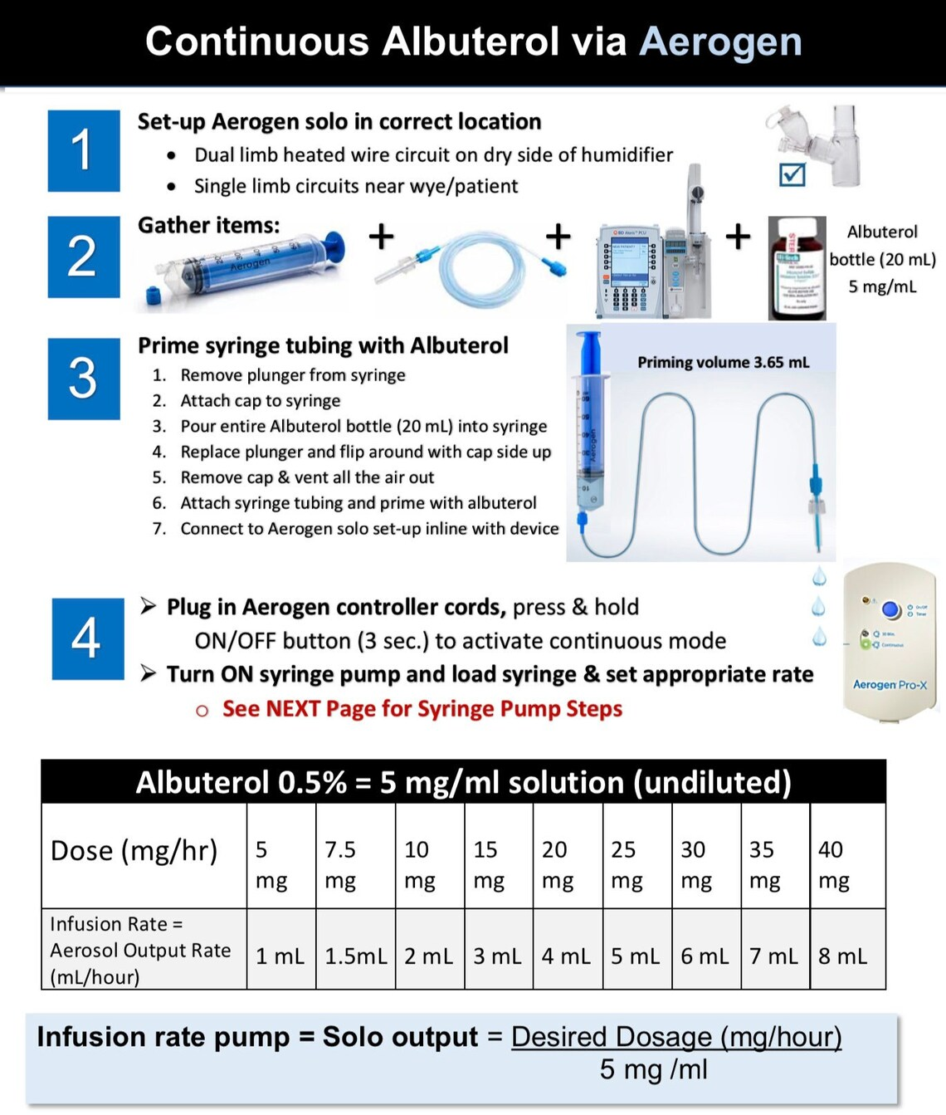
Continuous Salbutamol via Aerogen

Salbutamol 0.5% = 5mg/ml solution (undiluted)
Prime syringe tubing with Salbutamol
Salbutamol = Ventolin = Albuterol

12.5mg | 11.25mg | 10mg | 8.75mg | 7.5mg | 6.25mg | 5mg | 3.75mg | 2.5mg | Dose (mg/hr)
5mL | 4.5mL | 4mL | 3.5mL | 3mL | 2.5mL | 2mL | 1.5mL | 1mL | Infusion rate = Aerosal output Rate (mL/hour)

Fill the special 60mL aerogen syringe with
20mL Salbutamol 0.5% + 20mL NaCl 0.9% Salbutamol 0.25% = 2.5mg /mL
Infusion rate pump = Solo output = Desired Dose (mg/hour)
2.5mg/mL

